INTERNET PROTOCOL

|  |  |
| --- | --- |
| Reviewed by | V. Mamatha |
| Prepared by | M. Venkatanarayana |

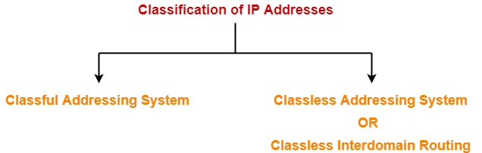

CLASSFUL ADDRESSING: -

This addressing is an IPv4 addressing architecture that divides addresses into five groups. Prior to classful addressing, the first eight bits of an IP address defined Classful the network a given host was a part of. This would have had the effect of limiting the internet to just 255 networks.

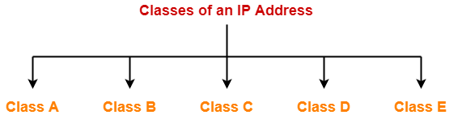

CLASS A: -

If the 32bit binary address starts with a bit 0, then IP Address belongs to class A.

In class A IP Address,

* The first 8 bits are used for the Network ID.
* The remaining 24 bits are used for the Host ID.

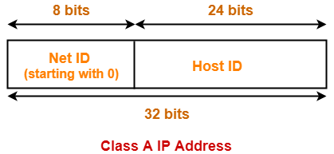

**Total Number Of IP Addresses-**

 Total number of IP Addresses available in class A

= Numbers possible due to remaining available 31 bits

= 231

### ****Total Number Of Networks-****

 Total number of networks available in class A

= Numbers possible due to remaining available 7 bits in the Net ID – 2

= 27 – 2

= 126

(The reason of subtracting 2 is explained later.)

### ****Total Number Of Hosts-****

 Total number of hosts that can be configured in class A

= Numbers possible due to available 24 bits in the Host ID – 2

= 224 – 2

(The reason of subtracting 2 IS 00000000 is for broadcasting and 127 is for loop back).

### ****Range Of 1st Octet-****

 We have-

* Minimum value of 1st octet = **0**0000000 = 0
* Maximum value of 1st octet = **0**1111111 = 127

From here,

* Range of 1st octet = [0, 127]
* But 2 networks are reserved and unused.
* So, Range of 1st octet = [1, 126]

## **Use-**

* Class A is used by organizations requiring very large size networks like NASA, Pentagon etc.

 CLASS B: -

If the 32bit binary address starts with bits 10, then IP Address belongs to class B.

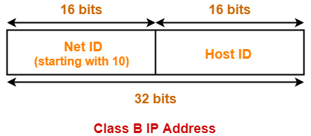

In class B IP Address,

* The first 16 bits are used for the Network ID.
* The remaining 16 bits are used for the Host ID.

### ****Total Number Of IP Addresses-****

 Total number of IP Addresses available in class B

= Numbers possible due to remaining available 30 bits

= 230

### ****Total Number Of Networks-****

 Total number of networks available in class B

= Numbers possible due to remaining available 14 bits in the Net ID

= 214

### ****Total Number Of Hosts-****

 Total number of hosts that can be configured in class B

= Numbers possible due to available 16 bits in the Host ID – 2

= 216 – 2

### ****Range Of 1st Octet-****

 We have-

* Minimum value of 1st octet = **10**000000 = 128
* Maximum value of 1st octet = **10**111111 = 191

So, Range of 1st octet = [128, 191]

## **Use-**

* Class B is used by organizations requiring medium size networks like IRCTC, banks etc.

 CLASS C: -

If the 32 bit binary address starts with bits 110, then IP Address belongs to class C.

In class C IP Address,

* The first 24 bits are used for the Network ID.
* The remaining 8 bits are used for the Host ID.



### ****Total Number Of IP Addresses-****

 Total number of IP Addresses available in class C

= Numbers possible due to remaining available 29 bits

= 229

### ****Total Number Of Networks-****

 Total number of networks available in class C

= Numbers possible due to remaining available 21 bits in the Net ID

= 221

### ****Total Number Of Hosts-****

 Total number of hosts that can be configured in class C

= Numbers possible due to available 8 bits in the Host ID – 2

= 28 – 2

### ****Range Of 1st Octet-****

We have-

* Minimum value of 1st octet = **110**00000 = 192
* Maximum value of 1st octet = **110**111111 = 223

So, Range of 1st octet = [192, 223]

## **Use-**

* Class C is used by organizations requiring small to medium size networks.
* For example- engineering colleges, small universities, small offices etc.

 CLASS D: -

If the 32bit binary address starts with bits 1110, then IP Address belongs to class D.

* Class D is not divided into Network ID and Host ID.



### ****Total Number Of IP Addresses-****

 Total number of IP Addresses available in class D

= Numbers possible due to remaining available 28 bits

= 228

### ****Range Of 1st Octet-****

 We have-

* Minimum value of 1st octet = **1110**0000 = 224
* Maximum value of 1st octet = **1110**1111 = 239

So, Range of 1st octet = [224, 239]

## **Use-**

* Class D is reserved for multicasting.
* In multicasting, there is no need to extract host address from the IP Address.
* This is because data is not destined for a particular host.

CLASS E: -

If the 32 bit binary address starts with bits 1111, then IP Address belongs to class E.

* Class E is not divided into Network ID and Host ID.



### ****Total Number Of IP Addresses-****

 Total number of IP Addresses available in class E

= Numbers possible due to remaining available 28 bits

= 228

### ****Range Of 1st Octet-****

We have-

* Minimum value of 1st octet = **1111**0000 = 240
* Maximum value of 1st octet = **1111**1111 = 255

So, Range of 1st octet = [240, 255]

## **Use-**

* Class E is reserved for future or experimental purposes.

CLASSLESS ADDRESSING: -

* Classless Addressing is an improved IP Addressing system.
* It makes the allocation of IP Addresses more efficient.
* It replaces the older classful addressing system based on classes.
* It is also known as **Classless Inter Domain Routing (CIDR)**.

## **CIDR Notation-**

CIDR IP Addresses look like-

**a.b.c.d / n**

* They end with a slash followed by a number called as IP network prefix.
* IP network prefix tells the number of bits used for the identification of network.
* Remaining bits are used for the identification of hosts in the network.

An example of CIDR IP Address is-

167.199.170.82 / 27

It suggests-

* 27 bits are used for the identification of network.
* Remaining 5 bits are used for the identification of hosts in the network.

FORMULA TO GET HOST ID: - **232-n**

HOST ID: - **232-27**  25=32 host id we want

HOST ID: - 25

|  |  |
| --- | --- |
| IP ADDRESS | BINARY FORMAT |
| CIDR IP :167.199.170.82 / 27 | 10100111.11000111.10101010.01010010 |
| First IP : 167.199.170.64 | 10100111.11000111.10101010.010**00000** |
| Last IP : 167.199.170.95 | 10100111.11000111.10101010.010**11111** |

HERE CHANGING LAST 5 HOST IDS. EXCEPT FIRST SLASH 27 BITS

WE CAN GET CLASSLESS ADDRESSING.

LINK 1: -https://www.gatevidyalay.com/tag/classful-addressing/

LINK 2: -https://www.gatevidyalay.com/classless-addressing-cidr/

LINK 3: -https://youtu.be/s_01dXiFkzc